**Select sum(total_price) as Total_Revenue from pizza_sales;**

**PIZZA SALES SQL QUERIES**



**Select sum(total_price)/count(distinct order_id) as Avg_Order_Value from pizza_sales;**

**select sum(quantity) as Total_Pizza_Sold from pizza_sales;**

**select count(distinct order_id) as Total_orders from pizza_sales;**

**select cast(cast(sum(quantity)as decimal(10,2))/cast(count(distinct order_id) as decimal(10,2)) as decimal(10,2)) as Avg_Pizza_per_order from pizza_sales;**



**#Daily Trend for Total Orders**

**SELECT DAYNAME(str_to_date(order_date,'%d-%m-%Y')) AS order_day, COUNT(DISTINCT order_id) AS Total_orders FROM pizza_sales GROUP BY order_day;**

1.DAYNAME(order_date) AS order_day: Extracts the name of the day (e.g., Monday, Tuesday)

2.STR_TO_DATE('18-09-2024', '%d-%m-%Y'): Converts the string '18-09-2024' to a DATE type. The format '%d-%m-%Y' specifies the input date format (day-month-year).

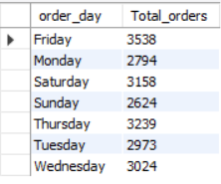

**#Monthly Trend for Total Orders**

**SELECT MONTHNAME(str_to_date(order_date,'%d-%m-%Y')) AS Month_Name, COUNT(DISTINCT order_id) AS Total_orders FROM pizza_sales GROUP BY Month_Name ORDER BY Total_Orders DESC;**

**#Percentage of sales by pizza Category**

**SELECT Pizza_category,sum(total_price)as Total_Sales,sum(total_price)*100/ (select sum(total_price) from pizza_sales where month(str_to_date(order_date,'%d-%m-%Y'))=1) as Percentage_of_Total from pizza_sales**

**where month(str_to_date(order_date,'%d-%m-%Y'))=1 group by pizza_category;**

month(str_to_date(order_date,'%d-%m-%Y'))=1 –indicates that the ouput is for the month of January.

Suppose month(str_to_date(order_date,'%d-%m-%Y'))=4 indicates output for month of April.

**# Percentage of Sales by Pizza Size**

**SELECT Pizza_size, Cast(sum(total_price) as decimal(10,2)) as Total_Sales, Cast(sum(total_price)*100/ (select sum(total_price) from pizza_sales where quarter(str_to_date(order_date,'%d-%m-%Y'))=1 )as decimal(10,2)) as Percentage_of_Total from pizza_sales**

**where quarter(str_to_date(order_date,'%d-%m-%Y'))=1**

**group by pizza_size order by Percentage_of_Total Desc;**

Quarter(str_to_date(order_date,'%d-%m-%Y'))=1 –indicates that the ouput is for the Quarter 1.

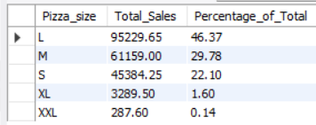

**#Top 5 Best Sellers by Revenue**

**select pizza_name,sum(total_price) as Total_Revenue from pizza_sales**

**group by pizza_name order by Total_Revenue desc limit 5;**

**#Bottom 5 Best sellers by Revenue**

**select pizza_name,sum(total_price) as Total_Revenue from pizza_sales**

**group by pizza_name order by Total_Revenue limit 5;**

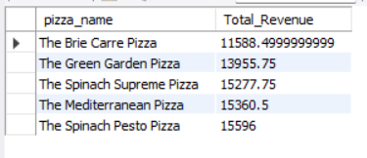

**#Top 5 Best Sellers by Total Quantity**

**select pizza_name,sum(quantity) as Total_quantity from pizza_sales**

**group by pizza_name order by Total_quantity desc limit 5;**

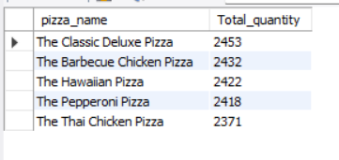

**#Bottom 5 Best sellers by Total Quantity**

**select pizza_name,sum(quantity) as Total_quantity from pizza_sales**

**group by pizza_name order by Total_quantity limit 5;**

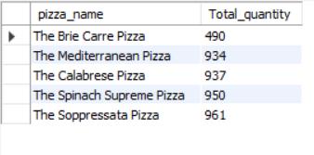

**#Top 5 Best Sellers by Total Orders**

**select pizza_name,count(distinct order_id) as Total_orders from pizza_sales**

**group by pizza_name order by Total_orders desc limit 5;**

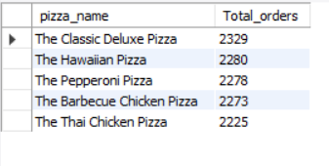

**#Bottom 5 Best sellers by Total Orders**

**select pizza_name,count(distinct order_id) as Total_orders from pizza_sales**

**group by pizza_name order by Total_orders limit 5;**

